FBE 5009 GIS
Midterm-1. 30.11.2023. – dur: 50 min. (sorular eşit puanlıdır, 5 pts. for each question)

1. GIS, DBMS (Database management systems) and CAD systems; which is wrong?
- DBMSs are widely used today from social media to banking systems.
- GIS is a DBMS in essence; they both manage a database.
- None.
- General purpose DBMSs like PostgreSQL and GISs; they can deal with both spatial and attribute data.
- CAD, used by an architect or a mechanical engineer is needed for rapid interactive editing operations.

2- Digital Elevation Models (DEM)s and spatial analyses; which is wrong?
- A DEM enables "2.5D" representation of the reality.
- For a "3D" representation we need a data model which is different from that of a DEM.
- none
- In a spatial analysis, If the user wants to click on a window in the second floor of a building in a city model and wants to get the coordinates of a corner point of that window, using a DEM for the representation of the city model would enable such an analysis.
- In a 3D representation, there would be many “z” values for a given x,y point in the system.

3- Web GIS, Ulusal Konumsal Veri Altyapısı (UKVA); which is wrong?
- After his UKVA proposal for Turkey in 1995 Cömert, has also proposed a “web services based implementation of UKVA” since 2000s.
- In Cömert’s UKVA proposal, each State agency would serve some Web services.
- As an example, Ministry of Environment and Urbanization would have a web service to show the earthquaqe valnurability of buildings.
- In Cömert’s UKVA proposal, a user would perform the spatial analyses using various web services of different providers.
- “TUCBS” is the official name used instead of “UKVA” in Turkey, which is in line with the international naming of the concept.
- None.

4- API (Application Programming Interface)s and Web APIs; which is wrong?
- None.
- API (Application Programming Interface) of a GIS is needed for users to write special purpose programs, like PyQgis API of Qgis to develop Python programs over Qgis.
- QGIS may use PostgreSQL as its DBMS software in the background.
- C++, Java are not Object-Oriented programming languages.
- There are two modes of GIS; one is the “Web based GIS”, and the other is “desktop GIS”, Qqis a desktop gis.
- To develop Web GIS applications there are “Web APIs” like twitter API.

5 -MCE -Multicriteria evaluation ; which is wrong ?
- Each pixel has a "score" indicating the relative "rank" of the pixel for a given criterion.
- Each criterion corresponds to a layer.
- What has been done in the MCE Lab app. is indeed a "weighted sum" operation
- In AHP (Analytical Hierarchy Process), weights are determined through pairwise comparison matrices;
- “Eigenvalues” and “Eigenvectors” concepts are not used in the AHP method developed by Saaty in 1970s.
- none

6-Topology building and topological error correction; which is wrong ?
- "cluster tolerance " is for automatic correction of errors when building topology in a GIS
- "order" of a node is a key concept in locating (finding) topological errors in building topology.
- It is not probable that you encounter "siliver polygons" as a topological error when you try to "intersect "two layers of the same geographical region.
- none
- A-GIS-software-reported "dangling arcs" or "dangling nodes" errors may not be errors considering the reality but they should be examined by the user anyway.

7- Topology and graph theory; which is wrong?
- Graph theory is also used for knowledge representation in Artificial İntelligence applications.
- in a GIS software it is imposed that a map must be a "planar graph"
- If a graph is a "connected graph" then you can find a "path" between any two points on the graph.
- If in the representation of your spatial data you have "from" and "to" fields in your file, it means that your map is represented as a "undirected graph".
- None

8- Topology and graph theory; which is wrong?
- A map must be a “Planar Graph”, where no two lines intersect at no location other than defined nodes.
- None
- A graph is a collection of points, lines, and polygons.
- One role of topology in the GIS software is to ensure geometrical integrity (correctness).
- One role of topology in the GIS software is to represent spatial relationships among features.

9- The “order” concept in topology; Which is wrong?
- Given a directed graph; If one arc is coming to and two others are going away from a node then the order of that node is “3”.
- It is employed by the “topology building” algorithms to locate “dangling arc” errors.
- It is a concept of “Graph theory”.
- None.
- If the order of a node is equal to “1” then there is certainly an error at that node.

10- DIME data representation; Which is wrong?
- It is a “topological-vector” representation.
- The word “representation” refers to the “encoding” of data within files.
- You have the “right” and “left” polygon data in DIME, by which you can compute all the neighbours of a polygon.
- None.
- DIME representation is an undirected graph representation of a map.

11- Consistency ratio in AHP; which is wrong?
- Thomas L. Saaty, the originator of AHP, defines incosistency as Consistency Index (CI) = (λmax-n) / n-1
- “λmax” is the maximum eigenvalue and “n” refers to matrix size.
- Saaty claims that a value of “0.1” for Consistency Ratio (CR) means consistent Weights
- None
- Saaty defines CR as CR=(CI / mean random CI), “mean random CI” refers to the randomly generated values (given as pre-computed tables) for large sized matrices.
12- Multi-Criteria Analysis (MCA) for “site selection”. What is applied is the formula in the box; which is wrong?
m
Si= Σ (eji * wj)
j=1

- “wj” means the weight of “jth” criterion
- “Si” is the final suitability score of “ith” pixel.
- None.
- “m” means the number of pixels.
- “eji”, means the score (rank) of “ith” pixel in the “jth” layer
- “m” means the number of layers.
- “m” means the number of criteria.

13- You are trying to delineate a drainage network; You start with a DEM layer and you obtain a new layer, “flow directions”, from this DEM by using 8 moves to “code” flow directions.
DEM layer
flow directions layer

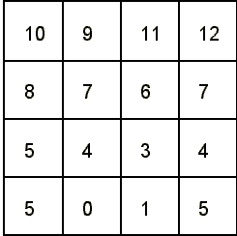 | 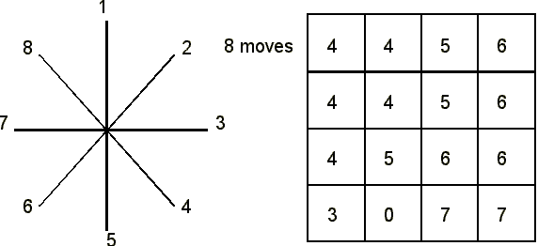

What type of spatial analysis operation is applied in this process according to Berry’s (1987) classification?
- Characterising neighborhood.
- None.
- Reclassification, based on the initial value of points.
- Reclassification, based on “size” and shape” of regions.
- Accumulated cost.

14- Now, using the “flow directions” layer of previous question (q.13), you obtain another layer, “final flow layer”, in which the value of a cell means the sum of the of the values of the cells which flow into that cell. In obtaining this layer from the “flow directions” layer you start by setting each cell to zero, then beginning at each cell, add one to it and all cells downstream of it, following the directions indicated in the network.
Final flow layer
flow directions layer

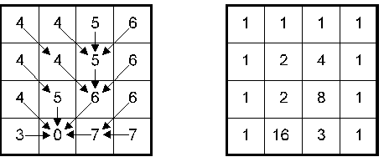

What type of spatial analysis operation is applied in obtaining the “final flow layer” according to Berry’s classification of spatial analysis operations?
- Characterising neighborhood.
- None.
- Reclassification, based on the nitial value of points.
- Reclassification, based on “size” and shape” of regions.
- Accumulated cost.

15. “Location – allocation” analysis; which is wrong?
- It is indeed an "optimization" problem.
- it requires a "iterative" solution,
- "Heuristics" might be needed to reach a solution in a "reasonable time".
- "- allocation " part of the problem is equivalent of "site-selection" problem in GIS.
- location-allocation problems may involve network analyses.
- None

16. Algorithms, data structures etc.; which is wrong?. (help: imagine searching for “6” in the array (3,7,9,16,28,22.,..))
- Search time of sequential search is given by O (N), N is the number of data (e.g, N=1000).
- Binary tree is a “data structure”
- Text, integer, Boolean, etc are called “data types”
- Raster, vector refers to “data representation”
- None.
- Search time of binary (tree) search is given by O (log₂N), N is the number of data.
- Sequential search is faster than binary search.
17. Web GIS, Open data etc.; trends in GIS?
- Open data is new approach which is based on the principle that State agencies or data providers “opens” their data for the others’ use.
- A Web service is a piece of program code accessible over internet. ( e.g. a Web service which carries out a “buffer” operation)
- A number of web services can be chained together in a certain workflow to perform a task like “determining solid waste disposal sites in Trabzon”, which is called Web Services composition (WSC).
- None.
- In your lab applications with QGIS, you have indeed practiced “Web based GIS” rather than “desktop GIS”.

18. Given a DEM layer and the formula below: Explain what kind of a map you can produce with this formula from this DEM. Can you apply the formula in the diagonal direction?

[δ z /δ x]_{i, j} = ( Z _{i+1, j} – Z _{i-1, j} ) / 2δx, δx: distance between cell centers (use δx =1)
Z _{i+1, j}
Z _{i-1, j}
Z _{i+1, j+1}
Z _{i, j+1}
Z _{i-1, j+1}
Z _{i+1, j-1}
Z _{i-1, j-1}
Z _{i, j-1}
Z _{i, j}

19.. write down the steps (in the right order) of MCE process with a brief description (1-2 sentences) of each step you applied in the lab application.

20.. write down the steps (in the right order) with a brief description (1-2 sentences) of each step of “kamulaştırma” lab application. List also what spatial analyses operations have you employed.

