Q1. Earth work: 30 points
Question: A pavement base layer is to be constructed in 30 days. Find the necessary truck numbers.
shift (hours/day) | 8+8
Base layer density (t/m³) | 2
Ѳtemporary (%) | 20
Ѳpermenant (%) | 9.8
Loader efficient (m³/saat) | 130
Truck loading volume capacity (m³) | 6
Truck engine power | 250
Truck empty weight (kgf) | 4250
Load and unload time (minutes) | 2.75
Wr (kgf/kgf) | 0.15
Work site efficiency (%) | 85
Project time duration (day) | 30
Max. trafik speed (km/hour) | 60
Base Layer
Lenght =14000 mt
10556 mt
Base Layer
12 mt
80 cm
Stone quarry
V₀
Slope= 0 % (%)= 0
Answer:
Soil
Excavated volume necessary (m³) | $$V0=\frac{Vk}{(1+Ѳk)}=\frac{14000*12*0.8}{(1+0.098)}=122404.37 m3$$
Excavated volume necessary per day (m3/day) | $\frac{Vk}{30}$ = $\frac{122404.37}{30}$= 4080
Loader
Loader efficiency (m3/day) | 130x(8+8)=2080
Loader number needed to complet the work in 30 days | $$\frac{4080}{2080}=1.96=2$$
V_{departure} (km/hours) | $$\frac{0.243x250}{14.25(0.15+0)}=28.42$$
V_{return} (km/hours) | $$\frac{0.243x250}{4.25(0.15+0)}=95>60 so take 60$$
Truck

Load (tons) | $$\frac{2x6 }{(1+0.2)}=10$$
t departure (minutes) | $$\frac{17.556}{28.42}=0.618 hours=37.06$$
t return (minutes) | $$\frac{17.556 }{60}=0.2926 hours=17.556$$
One period time (minutes) | 37.06+17.556+2.75=57.366
D _{truck} efficiency (m³/day) | $$\frac{0.85x6x60x(8+8) }{\left(1+0.2\right)x57.366}=71.122$$
Number of truck =$\frac{Deks}{Dtruck}$ | $$\frac{2x2080 }{71.122}=58$$
2x2080=4160

Q2. Students with only singel number (example 20509) will answer
15+15 (profile) +150 points (tables) borrow=transfer=50 mt
1 unit =100 m³

1 unit = 10 m
20 points

20
points
Draw the profile in the second graph and show the earth transfer directions
L dozer = ?
 | L (m) | V (m³) | (m⁴)

L skrayper =?
 | L (m) | V (m3) | (m4)

Q2. Students with only even numbers (example 20510) will answer
15+15 (profile) +15 points (tables) borrow=transfer=50 mt
20 points
1 unit =100 m³

1 unit = 10 m
20 points

20
points
Draw the profile in the second graph and show the earth transfer directions
L dozer = 28000/800=35m
 | L (m) | V (m³) | (m⁴)
10-110 | 50 | 400 | 20000
160-200 | 20 | 200 | 4000
200-240 | 20 | 200 | 4000
 |  | $$\sum{=800}$$ | $$\sum{=28000}$$

L skrayper =47000/400=117.5m
 | L (m) | V (m3) | (m4)
0-120 | 110 | 100 | 11000
120-270 | 120 | 300 | 36000
 |  | $$\sum{=400}$$ | $$\sum{=47000}$$

Q3. 25 points Find the average transfer distance ? Platform width= 7 mt.
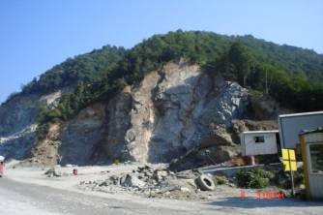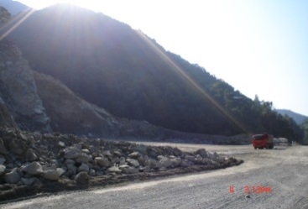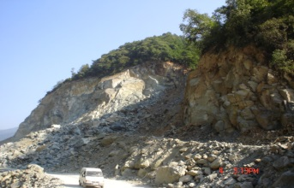

18+756

13+756

9+756

3+756

0+756
A B C

10 km 3 km 4 km

20 cm
25 cm

Solution: 3.756 -0.756 =3 km
Between A and B : 10+x=3+(10-x) => x=1.5 km
Between B and C : 3+y=4+(5-y) => y=3 km

Distance (m) | Volume($m^{3}$) | Moment($m^{4}$)
10000+3000/2=11500 | 7x0.25x3000=5250 | 60375000
10000+(1500/2)=10750 | 7x0.25x1500=2625 | 28218750
3000+4000+(4500/2)=9250 | 7x0.25x4500=7875 | 72843750
3000+(3000/2)=4500 | 7x0.2x3000=4200 | 18900000
4000+(2000/2)=5000 | 7x0.2x2000=2800 | 14000000
 | ∑Volume = 22750 m³ | ∑M = 194337500

$M_{avg}$= $\frac{194337500}{22750}$ = 8542.31 m

END
NO FURTHER QUESTION

