2/11/2015

BILL5180 - Digital Communications Homework
You are asked to create Modified outage probability expressions for Cooperative Decode and Forward Relaying and Selection Decode and Forward networks. Decode and forward relay networks can be visualised as in Figure 1.
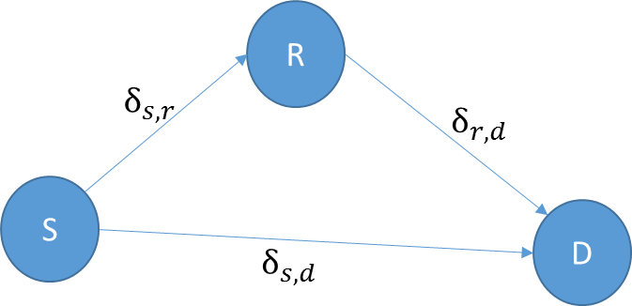
Figure 1: A simple relay channel
Where $δ$ stands for the ideally distributed Rayleigh random variable characterising the wireless channel gain.
The outage probability between the Source and Destination nodes is given as
Pr[$I_{D}<R$] = Pr[log(1+SNR ${| δ_{s,d}|}^{2}$) < R] (1)
Where log (1+SNR${| δ_{s,d}|}^{2}$) is the Shannon capacity of the link between the source and destination and R is the desired bit rate. Since, the channel gain parameter $δ_{s,d}$ is modelled as an ideally distributed Rayleigh random variable, the outage of the link can easily be shown to be;
Pr[$I_{D}<R$] = ${1-e}^{\frac{1-2^{R}}{SNR {δ }_{s,d}^{2} }}$ (2)
The details and outage probabilities of the mentioned relaying mechanisms can be found in Nicholas Laneman work in [1]. Your first task is to find exact outage probability expressions and useful rate regions for these relaying methods with a realistic assumption that the link efficiency between the nodes are given as;
$$ϑ_{s,d}=a_{s,d}\frac{T_{d(s,d)}}{T_{b(s,d)}+T_{i(s,d)}}$$
where$a_{s,d}$ is the spectral efficiency of the link and $T_{d(s,d)}$ is the data transmission period and $T_{b(s,d)}$ and $T_{i(s,d)}$ are the busy and idle intervals for the link during transmission of a single packet.
Your second task is to plot the outage probabilities for different rate regions (e.g. R=1/2 and R=2,5) and analyse your findings in terms of outage of such system within a wireless network setup.
[1] Laneman, J.N.; Tse, D.N.C.; Wornell, Gregory W., "Cooperative diversity in wireless networks: Efficient protocols and outage behavior," in Information Theory, IEEE Transactions on , vol.50, no.12, pp.3062-3080, Dec. 2004 doi: 10.1109/TIT.2004.838089

